Bezier More Complex Forms

# Adding The Two Curve Extensions

Before we can start working on more complex curves, we will need to first install two new extensions. You can go [here](../../Z-Extra-Linked-Tutorial-Files/2-Extensions/2-Extensions.html) to learn how to install these extensions.

# Starting to make Curve more complex

Ok, so let’s go back to the curve that we had been working on in the last tool, and start adding a few more segments. Remember to start working with a section, we need to click on that point. So, we want to start adding things to the top of our curve. And for this we will need to click on the mid-point of that Segment.

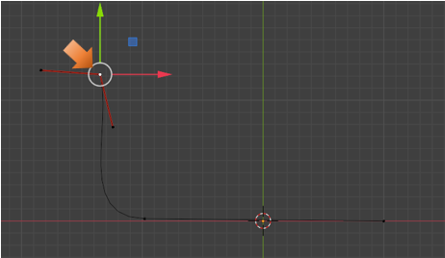

Now click on the E key on the keyboard and pull out a few more segments. I am using Free for my handle types on the added segments.

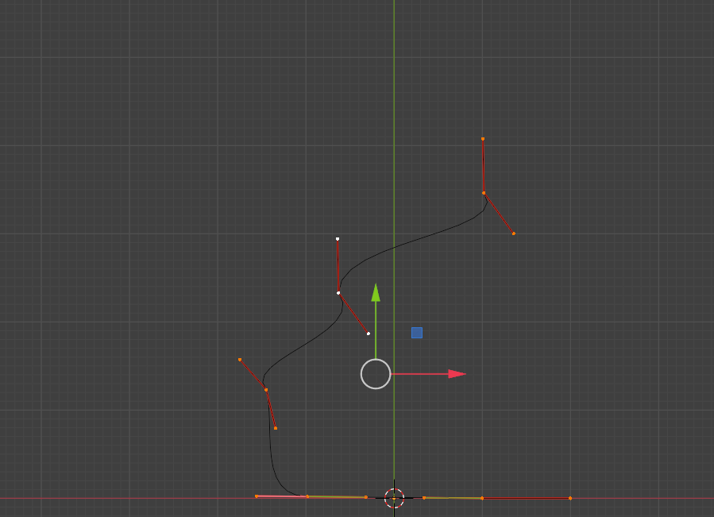

# Changing the Object’s Origin

We are going to be changing the origin of the object. Right now it is sitting in the center at the bottom of our curves. The origin is the orange dot and not the red and white ring around it.

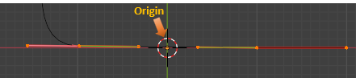

And this is why we needed to add those extensions that we pointed you to, at the beginning of this tutorial.

Hit the N key on your keyboard to open that menu at the right side of the viewport. If you added the Curve tool extension correctly, you should see an Edit tab. We want to open that section, below that says Sanitize.

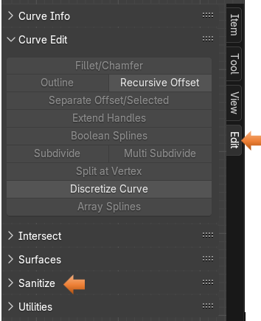

If you find a lot of the options greyed out, like I did above. You might have to toggle the Object Workspace Mode button and Edit Mode button to bring them to life.



Select those top handles

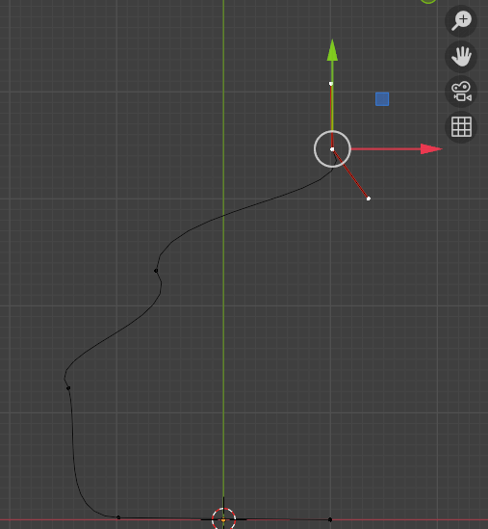

Keep an eye on that orange dot at the bottom.

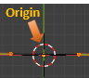

Then hit the button under Sanitize, on that menu on the right, that Says: Set Origin to Spline Start.

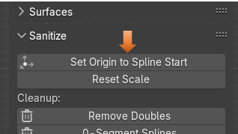

You will notice that the orange from that dot has disappeared. What it did was to send that origin to the mid- point on the handles that we have selected at the top. The dot will not turn orange, but it is there.

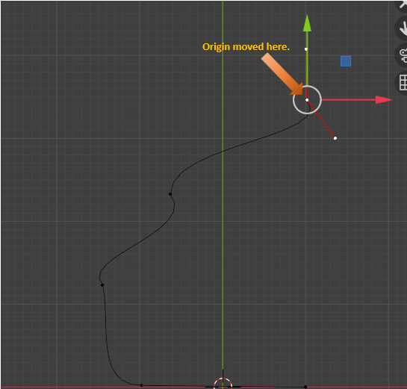

Notice the orange dot is no longer at the bottom inside of the cursor.

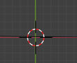

But instead, we want this mid- point to be our start. So, select this mid- point on the first section on the floor. We want to open that section in the menu on the right that is named utility.

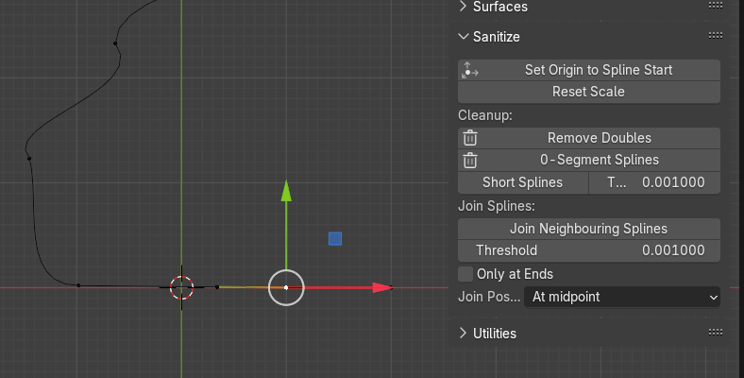

When you open up the Utilities section, you might have to scroll down a bit, but we want to hit the Set First Points button.

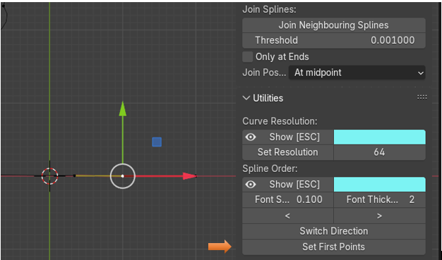

Now we can come back up and again press that Set Origin to Spline Start button for it to actually work correctly.

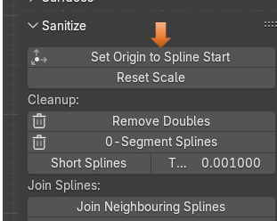

Now our origin should actually be here. On that mid-point of that first section

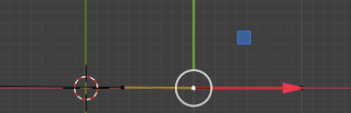

Now come out of Edit Mode, and move back into Object mode

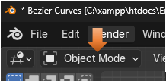

Hit the Item tab on the menu on the right.

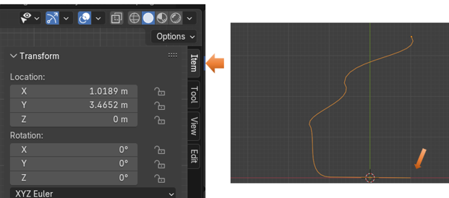

For the X location, we want to hit 0, and it should immediately pop that first mid-point, we allocated, and set it to the center point on the viewport.

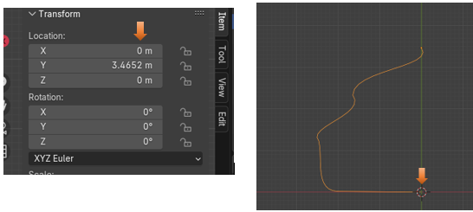

# Going Back to Edit Mode

Now go back into Edit mode

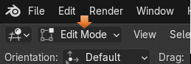

Make sure your orange dot did indeed move to this point. If you will need to select this point, and hit the Set First Points, under Utility, and Set Origin to Spline Start under Sanitize again.

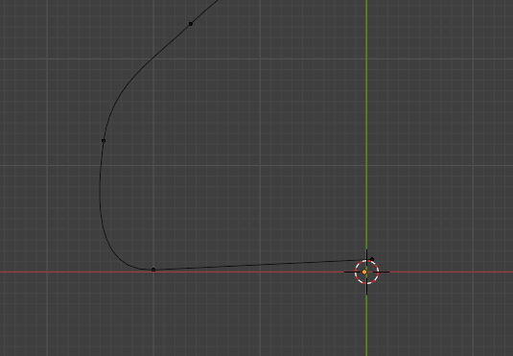

Move this point back into place by setting the Location of X, Y, and Z to be 0. This sets this exactly to that orange origin spot.

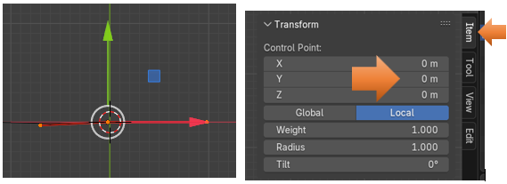

Select the top 3 sections that we created.

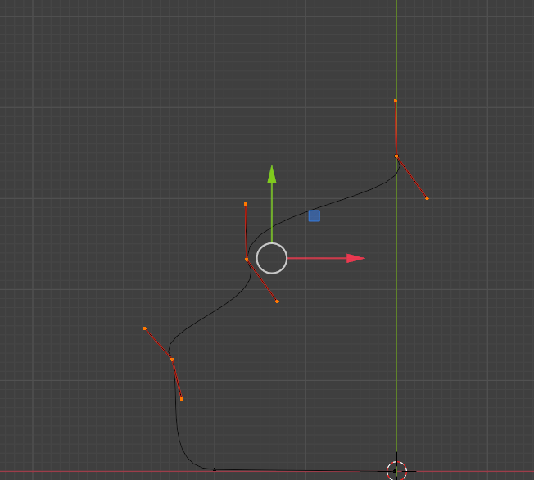

Now hit the V key to change the handle type. Then hit Automatic for the type.

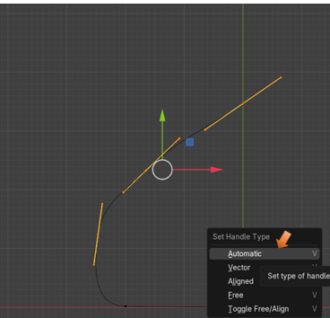

# To Control the Exact Location of a Mid-Point

<https://www.youtube.com/watch?v=f53GvpTIO2w>

